11/5/2019

ACME Company

South Metropolitan TAFE

Multi-Platform Report

Rapid Application Development

Table of Contents

Definition of Adaptive and Responsive Web Design 2

Responsive Web Design 2

Adaptive Web Design 3

Comparisons of Responsive Web Design and Adaptive Web Design 3

Responsive is Harder to Make 3

Adaptive is Less Flexible 3

Responsive Sites Load Faster 4

Is Responsive design better than Adaptive? 4

Conclusion: 4

Should you use Responsive or Adaptative design for your sites? 4

Bibliography 5

Glossary of Term 5

Cascading Style Sheets (CSS) 5

# 

FIGURE 1.1

# Definition of Adaptive and Responsive Web Design

## Responsive Web Design

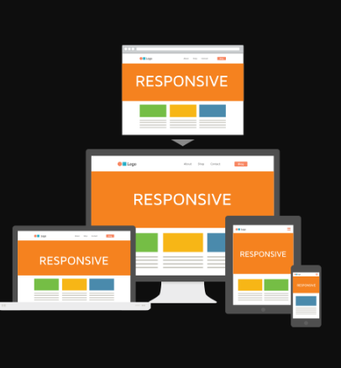Responsive Web Design provides an optimal viewing experience of a website, regardless of what types of device the user is using.

FIGURE 1.2 – Example of Responsive Design

## Adaptive Web Design

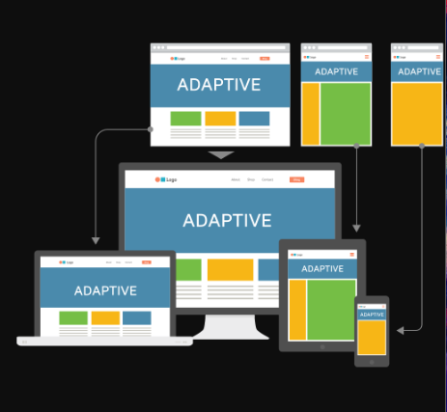Adaptive Web Design provides a multiple layout for multiple screen sizes and the layout used depends on the screen size used.

FIGURE 1.3 – Example of Adaptive Design

# Comparisons of Responsive Web Design and Adaptive Web Design

## Responsive is Harder to Make

Responsive Design are harder to implement due to the extra efforts needed for the site’s “CSS” in order to ensure that it functions well at any possible size. So, for Adaptive Design, you only need to make a few specific layouts which work on several screen sizes which makes it easier than making one layout that works for all of them.

## Adaptive is Less Flexible

The one disadvantages of using Adaptive Design is that the result do not always display the best for a wide variety of screen sizes. While for responsive site design, it will be able to works well on any kinds of screen sizes. Responsive sites can keep working on its own, adaptive sites may need some maintenance from time to time.

## Responsive Sites Load Faster

Responsive sites load faster because it only loads the one that works across all platforms but for adaptive sites it need to load all possible layouts. For adaptive sites, it has more layouts which it will take more time and resources to load.

# Is Responsive design better than Adaptive?

If you have in mind what specific devices your site must support, adaptive design might be easier and more efficient than Responsive. However, responsive design is good way for future-proofing a site against any possibility that a new device launched on the market.

# Conclusion:

## Should you use Responsive or Adaptative design for your sites?

Personally, I would choose Responsive Design as it is the safer option to go with your sites. It is because it required less maintaining as it will respond to any new screen sizes as they released which provides a longer lease of life for your sites, but Responsive design takes a lot of effort to implement. Responsive Design also improve the times taken to load your sites.

# Bibliography

*Responsive vs Adaptive Design – Which is Best for Mobile Viewing of Your Website?* (n.d.). Retrieved from Medium Well: http://mediumwell.com/responsive-adaptive-mobile/

Strachan, J. (2019, December 12). *Adaptive vs responsive web design*. Retrieved from UX Planet: https://uxplanet.org/adaptive-vs-responsive-web-design-eead0c2c28a8

# Glossary of Term

**Cascading Style Sheets (CSS)** - This is a stylesheet language used to describe the presentation of a document written in HTML or XML.